**Name: Session:**

**Programming I**

**Making PyTunes Music Player**

**Lab Exercise 11.1.2022**

**Part I – Building a Music Player**

In this exercise, you will be creating program to play music. I have placed a starter program (pyTunes_starter.py) on the server to help you get started. The path to this folder is:

\\Ada\Data Files\Programming I\Starter Code\Lab Exercise 11.1.2022\Music Player

In the folder, you also will find the following files:

playSound.py

playSong.py

pyTunes_starter.py

song1.ogg

song2.ogg

and several other .ogg files

Note: If you are using your own music, you will need to convert the .mp3 files into .ogg files using Audacity

Without the addition of additional modules, you can only use OggVorbis format sound files. Most of our music collection unfortunately consists of MP3 format files. Luckily, there is a wonderful piece of software called Audacity that can be used to not only edit sound files, but will allow us to convert our MP3 files into .ogg files. Note: Audacity can be found on the Computer Science disk that I gave you at the beginning of the year. In order for Audacity to handle MP3 files, you must install LAME.

When you have completed these programs, you are to print your documented source code, attach it to this handout, and turn it in.

At a minimum your documentation should contain:

# Name

# Programming Assignment 11/8/2019

1. Create a program that plays song1.ogg. You will need to place playSong.py and song1.ogg in the same project folder.
2. Now that you have one song playing, let’s make a menu which will allow the user to have a choice of songs. Add a menu item for playing a minimum of 5 songs. I have put a file pyTunes_starter.py on the server to get you started.

**Part II – Building a Music Streamer**

In this exercise we will study a technique for streaming music versus loading it into computer memory all at once. The advantage of this is technique is that we will have a lot more control of the music. For example, we will be able to pause the music, rewind the music, queue new music, etc. In this activity, you are to create a streaming music player. You program should have the following functionalities; Load a song, Play a song, Rewind a song, Stop the song, Pause and Unpause the song, Fadeout the song over a specific duration, and control the volume. The Escape key should cause the program to end and the music to stop. You will find the starter code in the folder

\\Ada\Data Files\Programming I\Starter Code\Lab Exercise 11.1.2022\Music Streamer

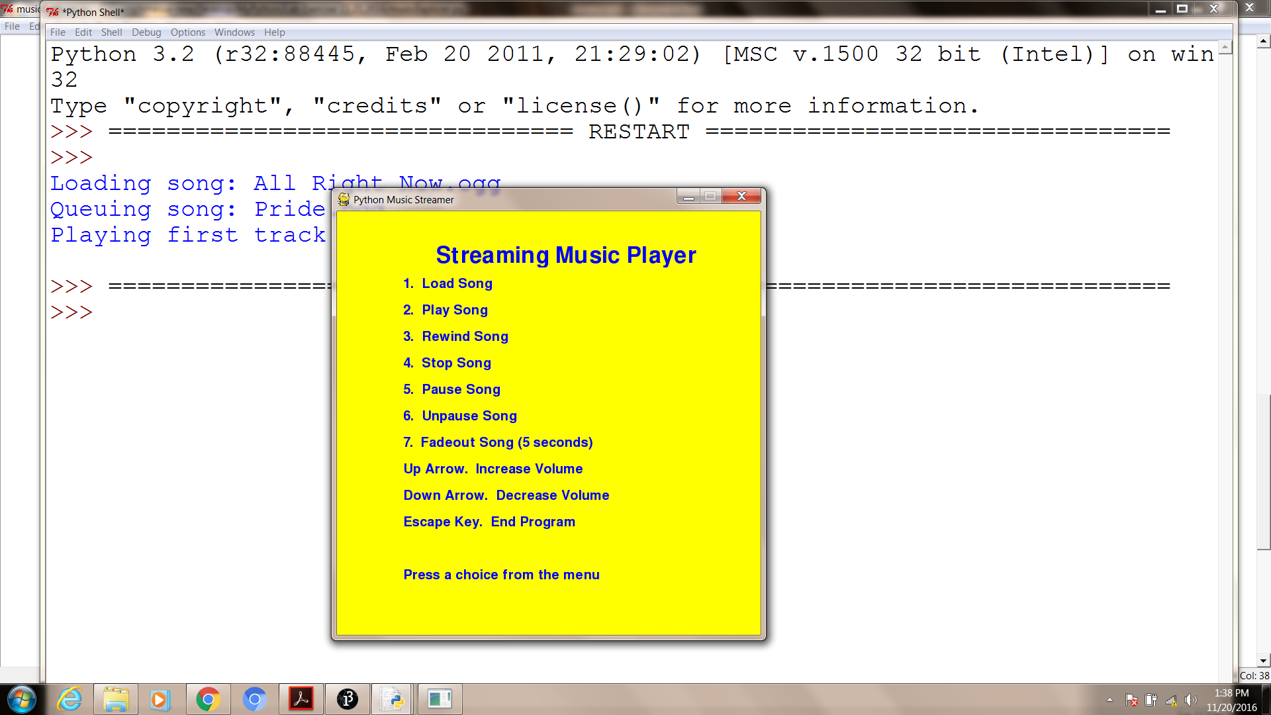

In order to accomplish this you will need to use the Pygame music module. You can find information on how to use that at the following location on the server:

\\ada\Data Files\Programming I\PyGame Docs

When you have your music streamer completed, submit your documented source code.